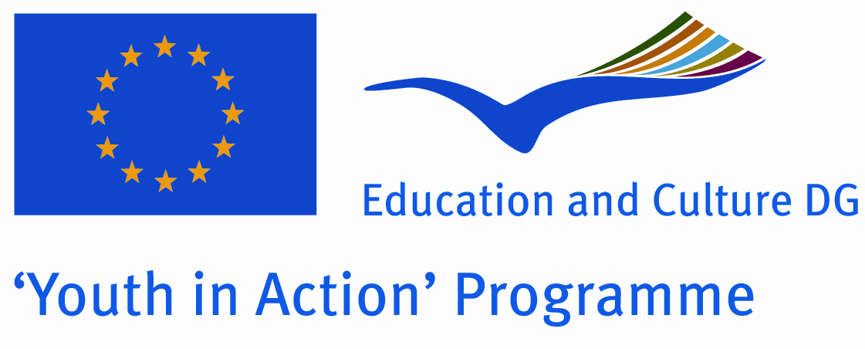 | Part III of the application for:  Action 1 - Youth for Europe  Sub-Action 1.1 - Youth Exchanges  Version valid as of 1 January 2010

Part III. Partner promoter(s)
A. Details of the partner
Name
Street address
Postcode |  |  |  |  |  |  | City
Region |  |  |  |  |  |  | Country
Email |  |  |  |  |  |  | Website
Telephone |  |  |  |  |  |  | Telefax
Person in charge of the project (contact person)
Family name (Ms/Mr) |  |  |  |  |  |  | First name
Position/function
Email
Telephone |  |  |  |  |  |  | Telefax
B. Profile and role of the partner
Type and status | Non profit/non governmental organisation |  |  |  | Public body Informal group of young people
 | Body active at European level in the field of youth (ENGO) |  |  |  | Other – please specify:
Activity level | Local |  | Regional |  |  | National |  |  | European/International
 | Member organisation of the applicant
Role | Sending Organisation |  |  | Host Organisation
Please give a short description of your organisation/group (regular activities, member of, etc.):

C. Preliminary agreement of the partner
I, the undersigned, on behalf of (repeat the name of the partner)
confirm our participation in each stage of the project (repeat the title of the project as stated in Part I):
I declare having reached an agreement with all the promoters involved in the project with regard to the share of EU grant my organisation/group is entitled to receive in order to implement the project.
I confirm that my organisation/group has not applied for funding for this project to another National Agency or to the Executive Agency.
Furthermore, I confirm my undertaking to ensure visibility of the European Union support for the project and to ensure dissemination and exploitation of its results.
Name in capital letters:
Place: |  | Signature:
Date:

